Hands-Free Reading
  - Preksha Ronak Shah, Han Luu, Lauren Durbin
  - 09/29/2026

GTA: Junyoung Kim
Lab Professor: Carla Zoltowski

Design Document
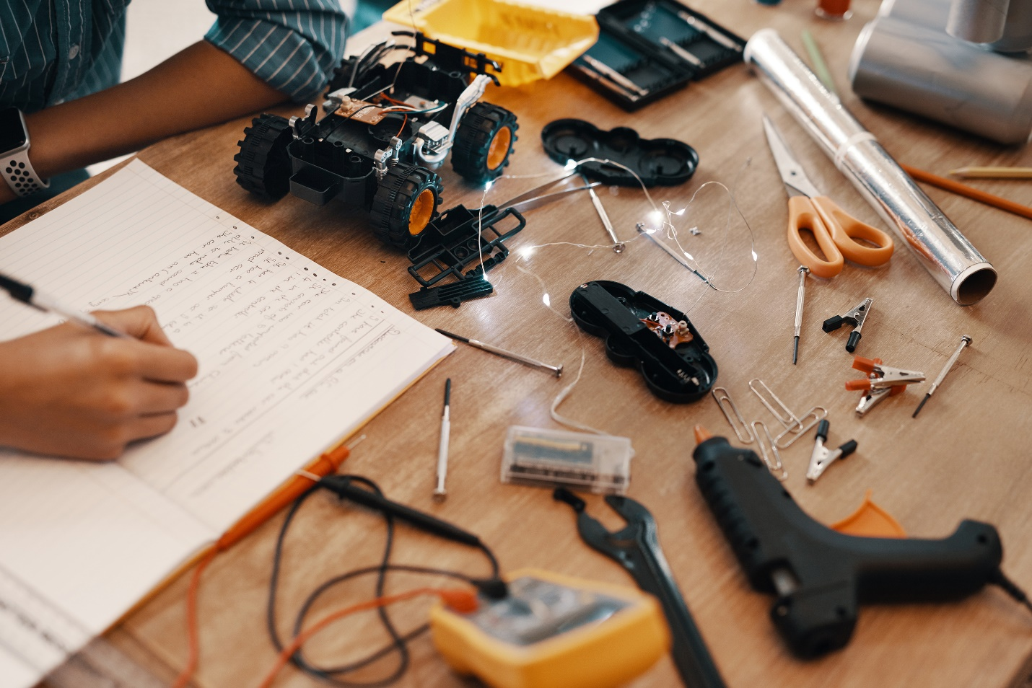
Figure 1: [Caption]

Contents
Introduction 3
Executive Description 4
Design Requirements 4
Requirements 4
Factors influencing requirements 4
Public Health, Safety, and Welfare 4
Global Factors 4
Social Factors 4
Environmental Factors 5
Economic Factors 5
System Overview 5
System Block Diagrams 5
System Activity Diagram 5
System Mechanical Design (Extra Credit) 5
Integration Approach 5
System Photographs 5
Subsystems 5
Subsystem 1: Vision 5
Subsystem Diagram 5
Specifications 5
Subsystem Interactions 5
Core ECE Design Tasks 6
Schematics 6
Parts 6
Algorithm 6
Theory of Operation 6
Specification Measurements 6
Standards 6
Subsystem 2: Robotics 6
Subsystem Diagram 6
Specifications 6
Subsystem Interactions 6
Core ECE Design Tasks 6
Schematics 6
Parts 6
Algorithm 7
Theory of Operation 7
Specification Measurements 7
Standards 7
Subsystem 3: Power 7
Subsystem Diagram 7
Specifications 7
Subsystem Interactions 7
Core ECE Design Tasks 7
Schematics 7
Parts 7
Algorithm 7
Theory of Operation 7
Specification Measurements 7
Standards 7
Subsystem 4: [subsystem name] 8
Subsystem Diagram 8
Specifications 8
Subsystem Interactions 8
Core ECE Design Tasks 8
Schematics 8
Parts 8
Algorithm 8
Theory of Operation 8
Specification Measurements 8
Standards 8
Subsystem 5: [subsystem name] 8
Subsystem Diagram 8
Specifications 8
Subsystem Interactions 9
Core ECE Design Tasks 9
Schematics 9
Parts 9
Algorithm 9
Theory of Operation 9
Specification Measurements 9
Standards 9
PCB Design 9
PCB Schematics 9
PCB Layout 9
Final Status 9
Team Structure 10
Team Member 1 10
Team Member 2 10
Team Member 3 10
Bibliography 10
Appendices 10
Appendix A: [NAME] 11

Revision Log
Date | Revision | Changes
8/28/2026 | v0.1 | Initial Release
9/29/2026

Introduction

Executive Description
Our project is a solution that allows users to read a physical paper book without using their hands. The solution consists of a vision component and a robotic component. The vision component will be used to track the user’s eye movement to determine when they are ready for the next page, and the robotic component will be used to flip the page for the user when ready.
This is in a fake reference [1]

Design Requirements

Requirements
- Orientation – Product usable when placed upright on a flat surface.
- Page Handling – Turning mechanism should not damage (scratch or tear) the pages
- Compatibility – System needs to work with a compatible book type
- Mostly hands-free - The user needs to be able to use the product entirely hands-free aside from the initial setup of the book on the holder.
- Easy to use and set up
- Portable – Product needs to be rechargeable and does not constantly need to be plugged in
- To be used in environment with standard lighting

Factors influencing requirements

Public Health, Safety, and Welfare
- A stable product is less likely to tip over or move unexpectedly during use. It also allows someone with limited hand/arm function to use it without needing to continuously stabilize it.
- An intuitive and easy-to-use design reduces the risk of improper operation that could create electrical or mechanical safety hazards.
- Careful consideration of the intensity and duration of emitted infrared (IR) radiation helps minimize potential risks to the user’s eyes from prolonged exposure.

Global Factors
- Using a USB-C charging port improves the product's global usability because USB-C is a widely adopted charging standard. Users can charge the device using commonly available USB-C power adapters rather than the product consisting of a proprietary, region-specific charger.

Social Factors
- A product that is mostly hands-free supports accessibility and independence for users with limited hand or arm function.
- Users with limited mobility should not need complicated physical manipulation to operate the device.

Environmental Factors
- The product is only designed to be used in indoor environments on stable, flat surfaces where lighting is sufficient. This will provide the optimal condition for the product to function as expected.
- Rechargeability can reduce reliance on disposable batteries.

Economic Factors
- The initial cost of the product should be as low as possible to make it more accessible to those it would benefit.
- Preventing damage to the user's books avoids replacement costs. It also makes the product practical for books that may be expensive, borrowed, or personally important.
- Rechargeability means the user does not need to spend money on buying replacement batteries.

System Overview
The system consists of three subsystems: vision, robotics, and power. The vision subsystem tracks the user’s eye movements to determine when the user is ready for the next page to trigger the robotic subsystem. The robotic subsystem flips the page for the user. The power subsystem handles the powering of all components and the rechargeable nature of the product.

System Block Diagrams
[Design Document 2][Add photos]

System Activity Diagram
[Design Document 2][Add photos]

System Mechanical Design (Extra Credit)
[Design Document 4]

Integration Approach
[Design Document 4] [Theory behind the system design, with reference to subsystem integration within your system]

System Photographs
[Design Document 4]

Subsystems

Subsystem 1: Vision

Subsystem Diagram
[Design Document 3] [image]

Specifications
- Eye tracking mechanism is used to trigger the page-turning

Subsystem Interactions
[Design Document 3]

Core ECE Design Tasks
[Design Document 3] [Explain which course helps accomplish the task]

Schematics
[Design Document 3] [image]

Parts
[Design Document 2][proposed parts]
[Design Document 4][Finalized List]

Algorithm
[Design Document 3]

Theory of Operation
[Design Document 3]

Specification Measurements
[Design Document 4][Every specification above should be validated with measurements]

Standards
[Design Document 1][Expected]
- [Standard Name]: [explain the connection to the project]
[Design Document 4][Finalized]

Subsystem 2: Robotics

Subsystem Diagram
[Design Document 3] [image]

Specifications
- [Design Document 3]

Subsystem Interactions
[Design Document 3]

Core ECE Design Tasks
[Design Document 3] [Explain which course helps accomplish the task]

Schematics
[Design Document 3] [image]

Parts
[Design Document 2][proposed parts]
[Design Document 4][Finalized List]

Algorithm
[Design Document 3]

Theory of Operation
[Design Document 3]

Specification Measurements
[Design Document 4][Every specification above should be validated with measurements]

Standards
[Design Document 1][Expected]
- IEEE 3004.8: IEEE Std 3004.8-2016 is an active IEEE recommended practice that provides comprehensive guidelines for selecting and applying motor protection schemes in industrial and commercial power systems.
[Design Document 4][Finalized]

Subsystem 3: Power

Subsystem Diagram
[Design Document 3] [image]

Specifications
- [Design Document 3]

Subsystem Interactions
[Design Document 3]

Core ECE Design Tasks
[Design Document 3] [Explain which course helps accomplish the task]

Schematics
[Design Document 3] [image]

Parts
[Design Document 2][proposed parts]
[Design Document 4][Finalized List]

Algorithm
[Design Document 3]

Theory of Operation
[Design Document 3]

Specification Measurements
[Design Document 4][Every specification above should be validated with measurements]

Standards
[Design Document 1][Expected]
- IEEE 1625: IEEE 1625 is an Institute of Electrical and Electronics Engineers (IEEE) standard for the design, quality, and safety of rechargeable lithium-ion and lithium-ion polymer battery systems used in multi-cell mobile computing devices like laptops
[Design Document 4][Finalized]

Subsystem 4: [subsystem name]

Subsystem Diagram
[Design Document 3] [image]

Specifications
- [Design Document 3]

Subsystem Interactions
[Design Document 3]

Core ECE Design Tasks
[Design Document 3] [Explain which course helps accomplish the task]

Schematics
[Design Document 3] [image]

Parts
[Design Document 2][proposed parts]
[Design Document 4][Finalized List]

Algorithm
[Design Document 3]

Theory of Operation
[Design Document 3]

Specification Measurements
[Design Document 4][Every specification above should be validated with measurements]

Standards
[Design Document 1][Expected]
- [Standard Name]: [explain the connection to the project]
[Design Document 4][Finalized]

Subsystem 5: [subsystem name]

Subsystem Diagram
[Design Document 3] [image]

Specifications
- [Design Document 3]

Subsystem Interactions
[Design Document 3]

Core ECE Design Tasks
[Design Document 3] [Explain which course helps accomplish the task]

Schematics
[Design Document 3] [image]

Parts
[Design Document 2][proposed parts]
[Design Document 4][Finalized List]

Algorithm
[Design Document 3]

Theory of Operation
[Design Document 3]

Specification Measurements
[Design Document 4][Every specification above should be validated with measurements]

Standards
[Design Document 1][Expected]
- [Standard Name]: [explain the connection to the project]
[Design Document 4][Finalized]

PCB Design

PCB Schematics
[Design Document 3]

PCB Layout
[Design Document 4]

Final Status
[Design Document 6]

Team Structure

Team Member 1
Preksha Ronak Shah
Contact: shah880@purdue.edu
Team Role: External Communication
Major: Electrical Engineering
Bio: I am a fourth-year Electrical Engineering student at Purdue University with experience in embedded systems, PCB design, sensors, and microcontrollers. I am interested in applying my technical experience to this project while developing new skills in robotics and computer vision. I hope to contribute to creating a practical and accessible device that allows users to interact with physical books more independently.

Team Member 2
Lauren Durbin
Contact: durbin7@purdue.edu
Team Role: Internal Communication
Major: Electrical Engineering
Bio: I am a senior in Electrical Engineering at Purdue, and I have concentrations in AI/ML and Automatic Control. I am interested in working in an automation or controls role following graduation, and some components of this project align with that. I have experience with machine and computer vision from previous internship experiences and am currently in an introductory robotics course, and I expect to apply all of this knowledge to this application.

Team Member 3
Han Luu
Contact: luum@purdue.edu
Team Role: Purchasing
Major: Electrical Engineering
Bio: I’m a senior in Electrical Engineering and interested in power systems. I have had internship experience in power systems as well as handling DC high-voltage lines for my club, so I am comfortable to be a primary contributor to the charging component of this project as well as helping out with the robotics component.

Bibliography
[1] | Beasley, "ECE 49022 Fake Artical," Beasley Centenial, vol. 1, no. 2, p. 3, 2050.

Appendices
[This section is mainly designed for code. You can directly generate a somewhat decent display of your code file or psuedo code by using the template provided below. You can have as many appendix as you want. In the document, you can refer to the code posted here instead of pasting the whole code in the body.]

Appendix A: [NAME]
[Insert code]

